**LAB#2**

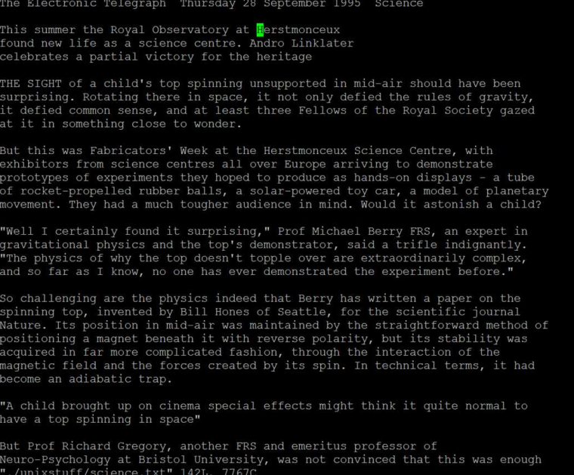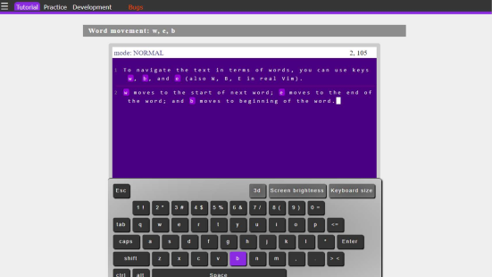**Activity 1: The vim Text Editor**

**Activity 2**

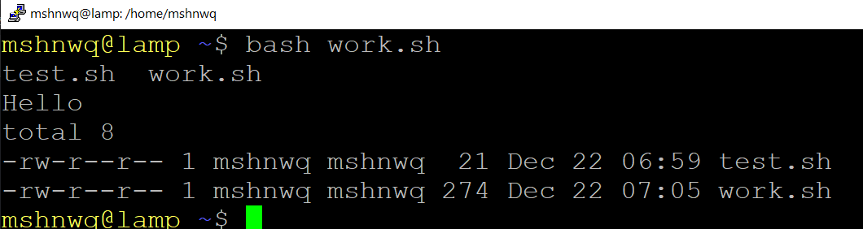

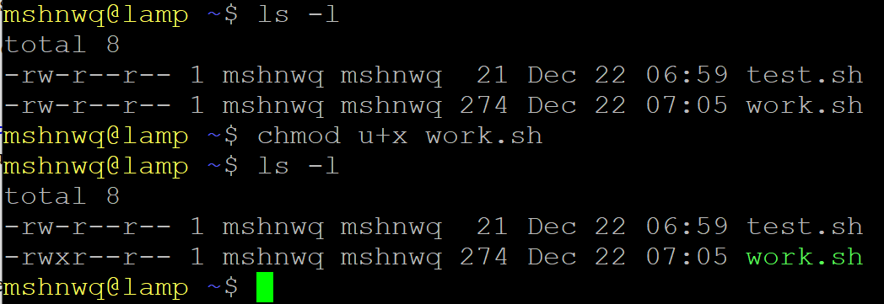

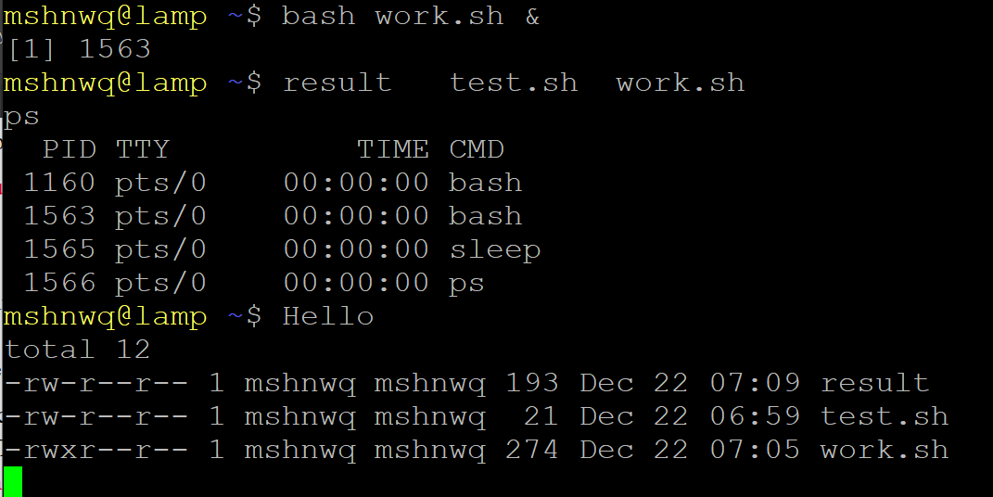

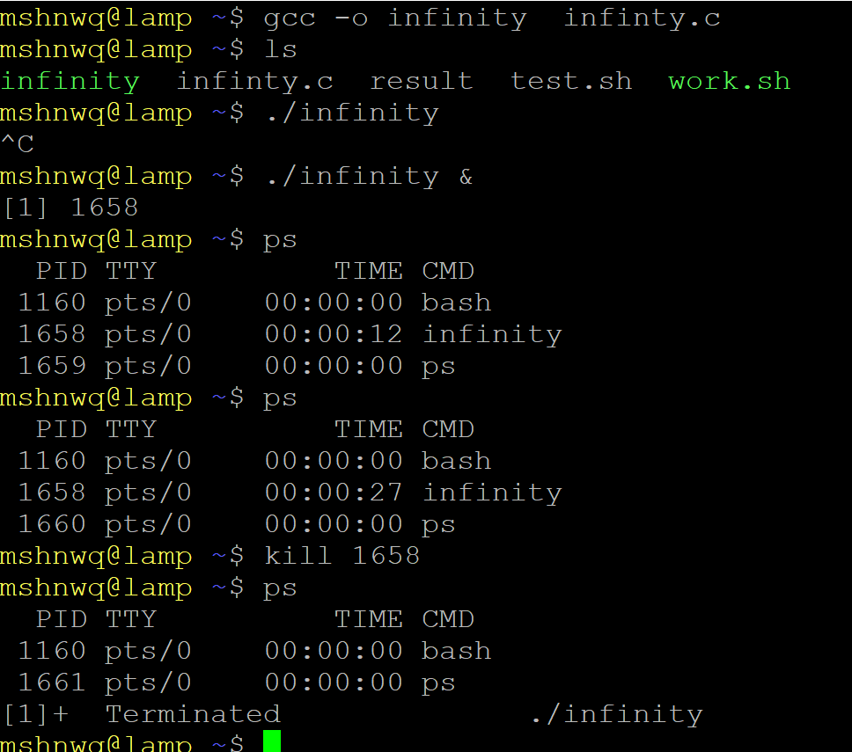

**Activity 3:**

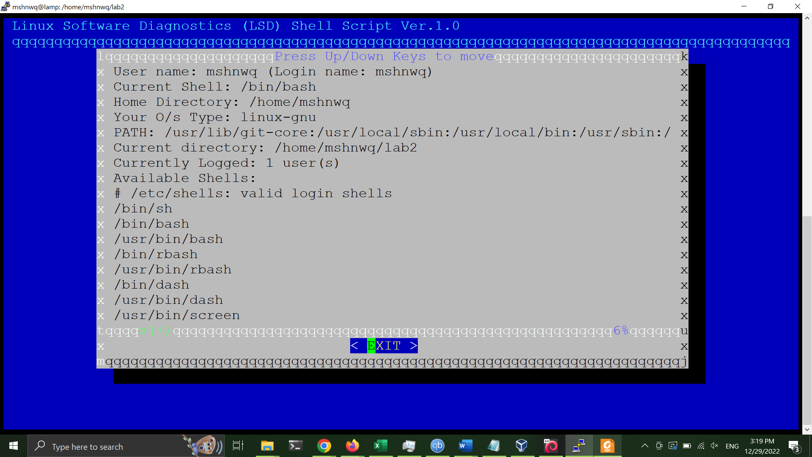

**Activity 4:**

